Bread Mixes
One Mix – Three Ways to Bake Bread

Bake homemade bread with our bread mix and some common kitchen items.
This versatile bread mix makes it easy to bake bread by three different methods:
- Bread machine
- Traditional
- Quick bread (the most popular way to use our mix)
No bread making skills are required for the Quick Bread method. All you need are a can of beer, baking powder, and butter. In an hour, you will have hot bread fresh from the oven.
We offer five bread mixes: Tuscan, French Herb, Dill, Cinnamon Raisin and White. All mixes are $5 each.
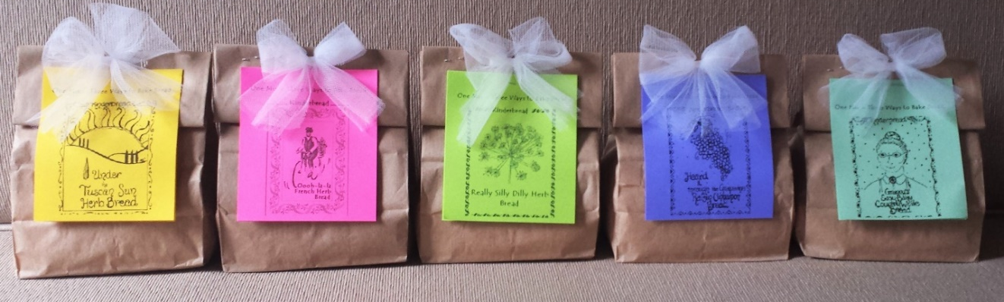
For more information, please contact Gretchen at gretheltman@gmail.com

